GannLine Oversimplified Trading

…called this way ‘cause the three initial letters form the beginning of my surname (GOT) ☺
I wanna show you a simple way of trading the market with Gann Lines.
I will take intraday (4 min) Dax future today action, so there’s no cherry pickin’…

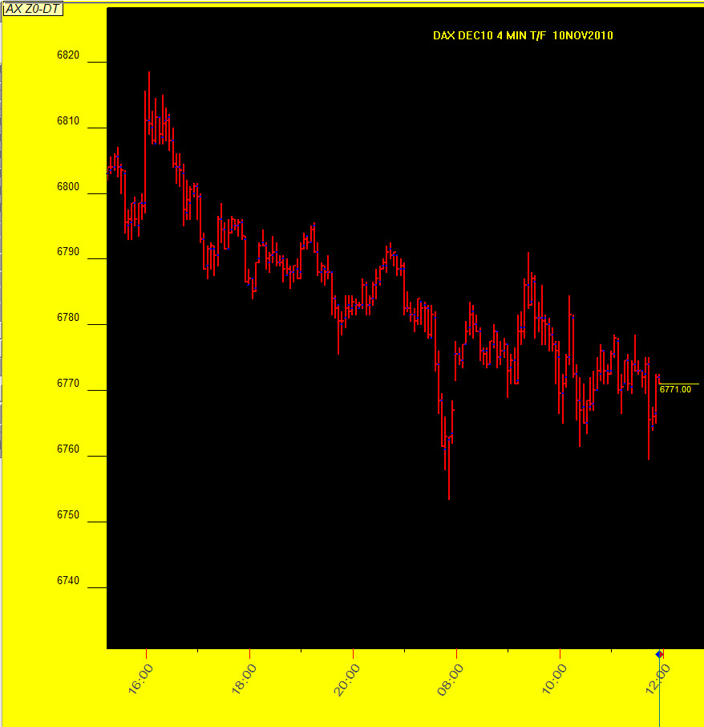

We start to draw fm last yesterday high (6818.50) a Gann Line (aka Gann Fans) with this inclination:
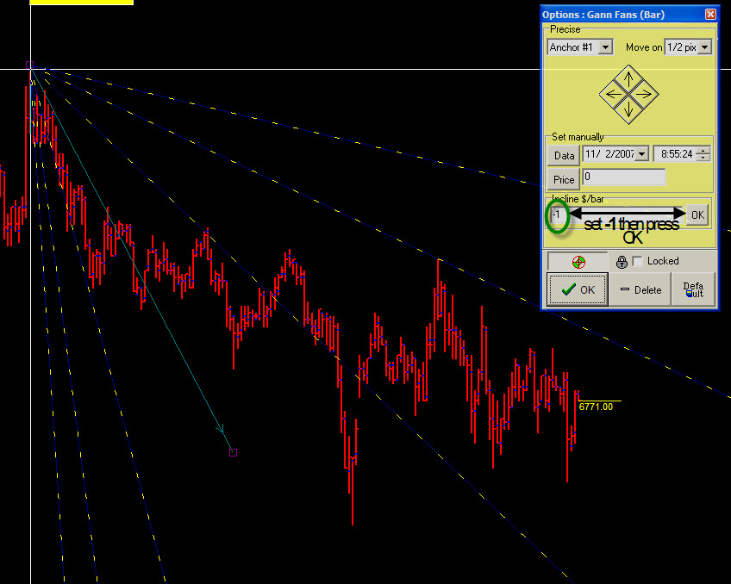

Remember Gann Lines (there’re many theories but this is the only I agree with) inclination must be always 2^n (where n=1,2,3,4…. or –1,-2,-3,-4…)

Now we choose some swings to use for next projections:
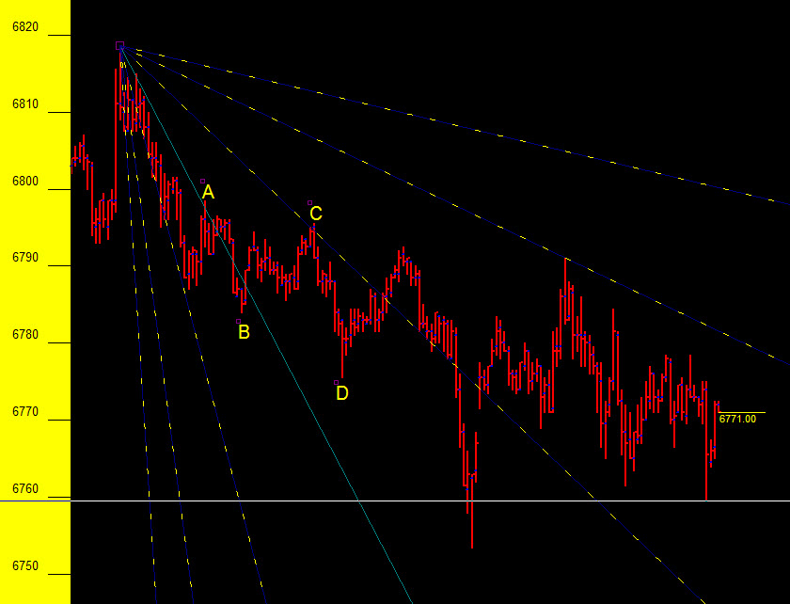

After this, we draw a vertical line from A to reach the first GL then draw an horizontal line ‘till touch the next GL and then draw another vertical line; this point will be a “sensitive point”, many time are reversals, sometime accelerations.

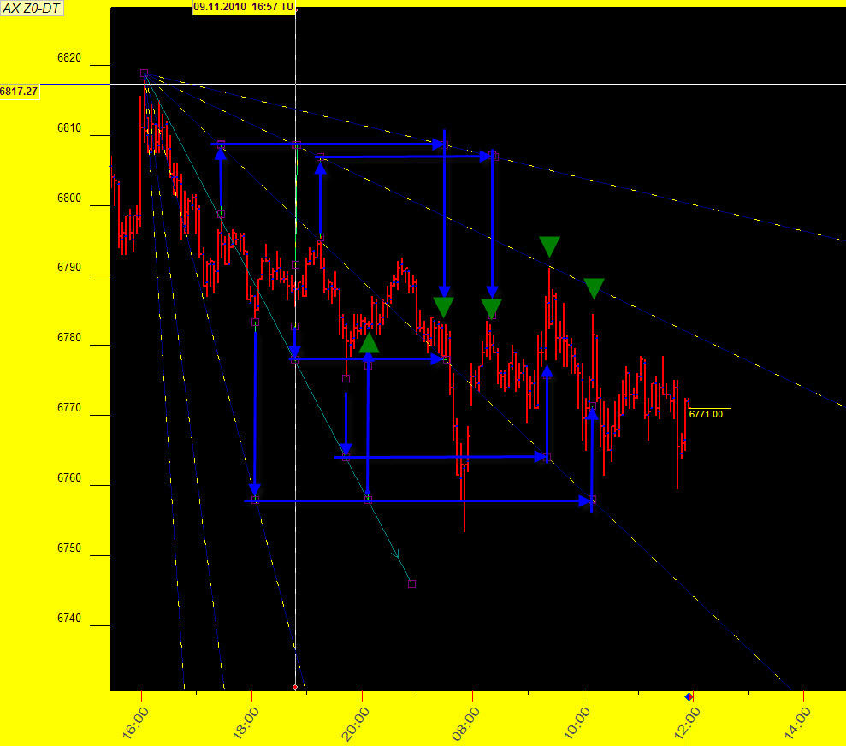

Naturally we can use the same method in daily chart:
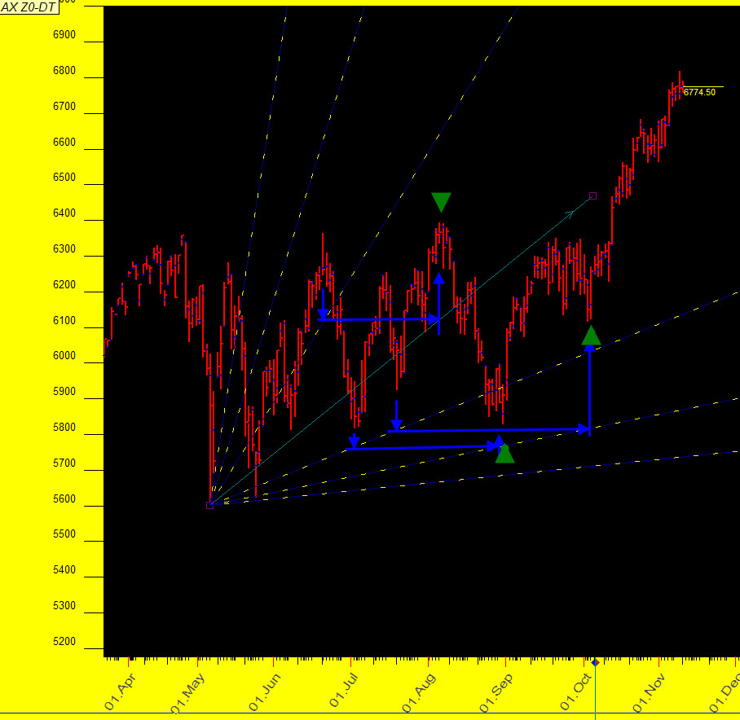

In this case GannLines inclination will be = 8 (2^3).

